Name: Maloth Aditya
Roll No.: 120CS0124

Find the shortest path to node ‘A’ for the following AND-OR graph using the AO* algorithm. Below the Node given is the heuristic value, i.e., h(n). Edge length is considered as 1.
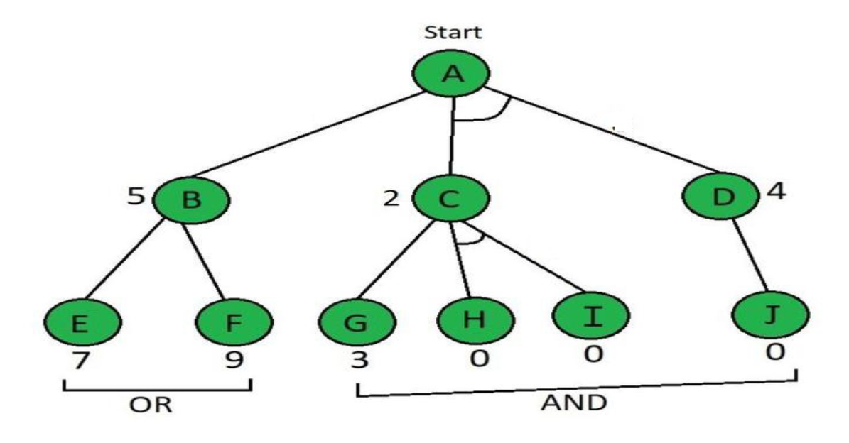
CODE:
# 12 September 2023
# Find the shortest path to node 'A' for the given AND-OR graph using the AO* algorithm. Below the Node given is the heuristic value, i.e., h(n).
# Edge length is consideredas 1, i.e., g(n)=1

#minCost returns the minimum cost for the shortest path to node 'A'
minCost = 1000000

def Cost(H, condition, weight = 1):
cost = {}
global minCost
minCost = 1000000
if 'AND' in condition:
AND_nodes = condition['AND']
Path_A = ' AND '.join(AND_nodes)
PathA = sum(H[node]+weight for node in AND_nodes)
cost[Path_A] = PathA
minCost=min(minCost,PathA)

if 'OR' in condition:
OR_nodes = condition['OR']
Path_B =' OR '.join(OR_nodes)
PathB = min(H[node]+weight for node in OR_nodes)
cost[Path_B] = PathB
minCost=min(minCost,PathB)
return cost

def updateCost(H, Conditions, weight=1):
Main_nodes = list(Conditions.keys())
Main_nodes.reverse()
least_cost= {}
for key in Main_nodes:
condition = Conditions[key]
print(key,':', Cost(H, condition, weight))
c = Cost(H, condition, weight)
H[key] = min(c.values())
least_cost[key] = Cost(H, condition, weight)
return least_cost

def shortestPath(Start,Updated_cost, H):
Path = Start
if Start in Updated_cost.keys():
Min_cost = min(Updated_cost[Start].values())
key = list(Updated_cost[Start].keys())
values = list(Updated_cost[Start].values())
Index = values.index(Min_cost)

# FIND MINIMIMUM PATH KEY
Next = key[Index].split()
# ADD TO PATH FOR OR PATH
if len(Next) == 1:

Start =Next[0]
Path += ' <- ' +shortestPath(Start, Updated_cost, H)
# ADD TO PATH FOR AND PATH
else:
Path +=' <- ('+key[Index]+') '

Start = Next[0]
Path += '[' +shortestPath(Start, Updated_cost, H) + ' + '

Start = Next[-1]
Path += shortestPath(Start, Updated_cost, H) + ']'

return Path

H = {'A': -1, 'B': 5, 'C': 2, 'D': 4, 'E': 7, 'F': 9, 'G': 3, 'H': 0, 'I':0, 'J':0}

Conditions = {
'A': {'OR': ['B'], 'AND': ['C', 'D']},
'B': {'OR': ['E', 'F']},
'C': {'OR': ['G'], 'AND': ['H', 'I']},
'D': {'OR': ['J']}
}
# all the edge length are 1
weight = 1
# new cost based on the AO* algorithm
print('New Heuristic:')
UpdatedCost = updateCost(H, Conditions, weight=1)
print()
print()
print('Shortest Path :\n',shortestPath('A', UpdatedCost,H))
print('Cost:', minCost)

OUTPUT:
